**Project Design Phase**

**Solution Architecture**

|  |  |
| --- | --- |
| Date | 27 June2025 |
| Team ID | LTVIP2025TMID56990 |
| Project Name | Shopsmart |
| Maximum Marks | 4 Marks |

**Solution Architecture:**

Solution architecture is a complex process – with many sub-processes – that bridges the gap between business problems and technology solutions. Its goals are to:

* Find the best tech solution to solve existing business problems.
* Describe the structure, characteristics, behavior, and other aspects of the software to project stakeholders.
* Define features, development phases, and solution requirements.
* Provide specifications according to which the solution is defined, managed, and delivered.

**Example - Solution Architecture Diagram:**

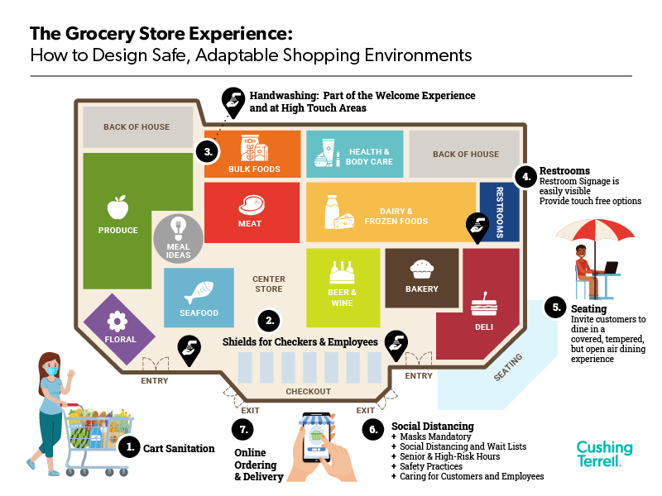

*Figure 1: Architecture and data flow of the voice patient diary sample application*

**Reference:** **https://www.google.com/url?sa=i&url=https%3A%2F%2Fcushingterrell.com%2Fthe-grocery-store-experience-how-to-design-safe-adaptable-shopping-environments%2F&psig=AOvVaw2DEc8akeO-0aZMhkehId05&ust=1751133563805000&source=images&cd=vfe&opi=89978449&ved=0CBQQjRxqFwoTCICL5YKXko4DFQAAAAAdAAAAABAE**